**Supplementary figure:**

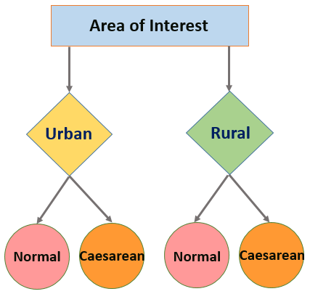

Schematic diagram of the experimental design.