Appendix 1: Ethical approval 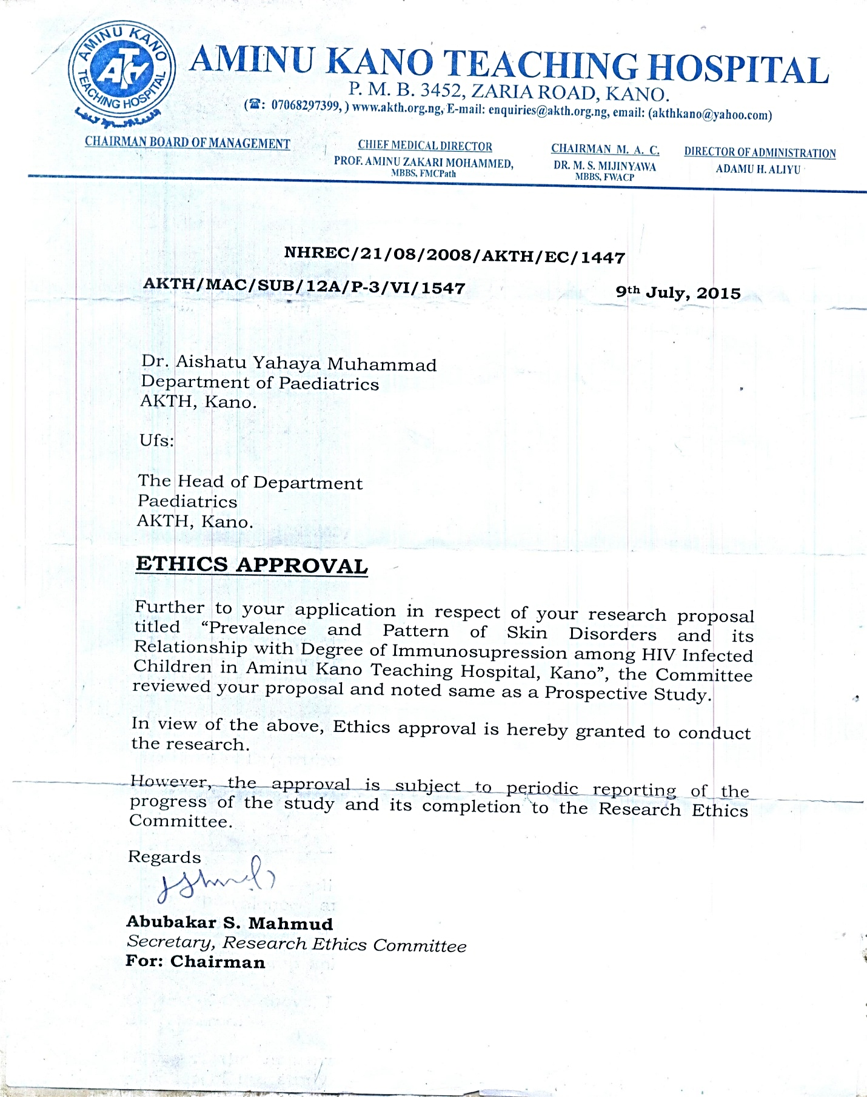

Appendix 2: Socio-economic classification scheme by Oyedeji.
In this method the social class of each child is determined from the occupational and educational level of both parents using standard scoring scales on both the occupation and educational level for each parent. The first scale scores the different occupational categories 1-5 from professional to unemployed. The occupations will thus be scored as:
For occupation
Class occupation
  - Senior Public Servants, Professionals, Managers, Large scale traders, businessmen and contractors.
  - Semi-professionals example Technicians, printers, Senior Public servants, Senior School Teachers.
  - Medium grade traders, insurance agents, policemen and Medium grade public servant.
  - Drivers, artisans, junior public civil servants and similar Grades.
  - Petty traders, labourers and similar grades and subsistence Farmers.
For Educational Status
Class educational attainment
- University graduates and postgraduate certificates.
- School certificate holders ordinary level (GCE) who also had teaching or other professional training.
- Ordinary school certificate or grade II teachers certificate Holders. West African School Certificate or equivalents.
- Modern three and primary six certificate holders example JSS3.
- Those who could either just read and write or were Illiterate with no formal education.
The social class that will allocated for the family will be the mean of four scores (two for the father and two for the mother) to the nearest whole number. For example, to determine the social class of a child whose father is a graduate bank manager and mother who is a registered nurse, the father will score 1 for education and 1 for occupation, the mother will score 2 for her occupation and 2 for education giving a total of 6 with a mean of 1.5 (taking this to the nearest whole number) the social class of the child will be 2.

